May 2026 BOM│The One with Polka-Dots

Yes, yes, yes…another adapted block from Tula Pink’s 100 Modern Quilt Blocks. I’m short on inspiration, and these blocks are speaking to me. This one is No.87, pages 194-95. It’s also quick, and lately I think we are all pressed for time!

Rules, using ¼” seams:
- Choose a POLKA-DOT for the big section of the square.
- Choose a solid for the small corner of the square.
- Coordinate the background.
- When the block is completed you will have a 12-½” square block…DO NOT TRIM!

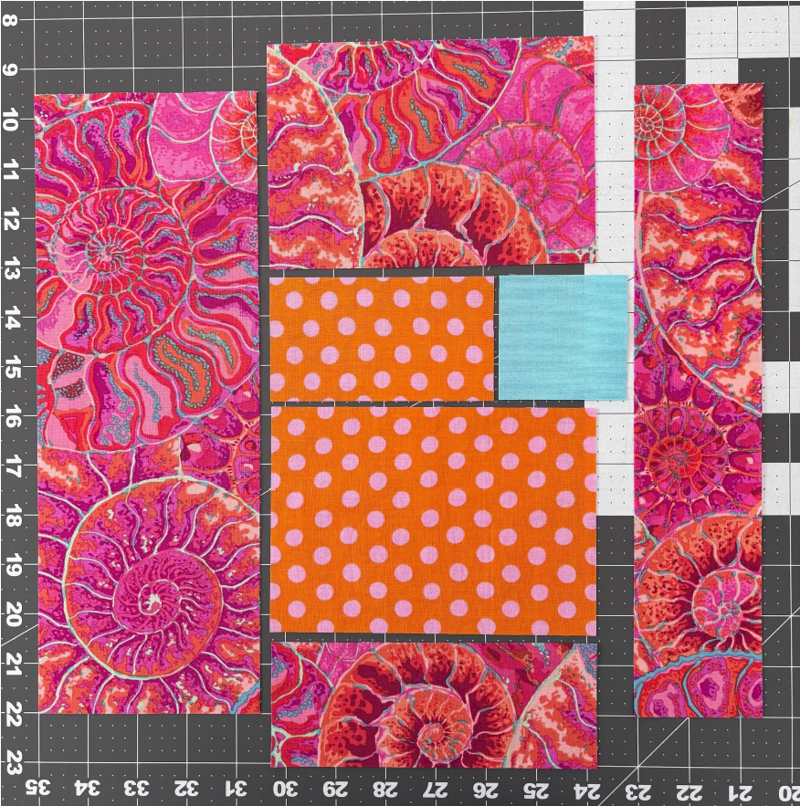
Cut, and lay out your block:

A–Background
(1) 6-½” x 4-½” (1) 6-½” x 2-½”
(1) 12-½” x 4-½” (1) 12-½” x 2-½”

B–Polka-Dot
(1) 2-½” x 4-½” (2) 6-½” x 4-½”

C–Solid square (1) 2-½” x 2-½”

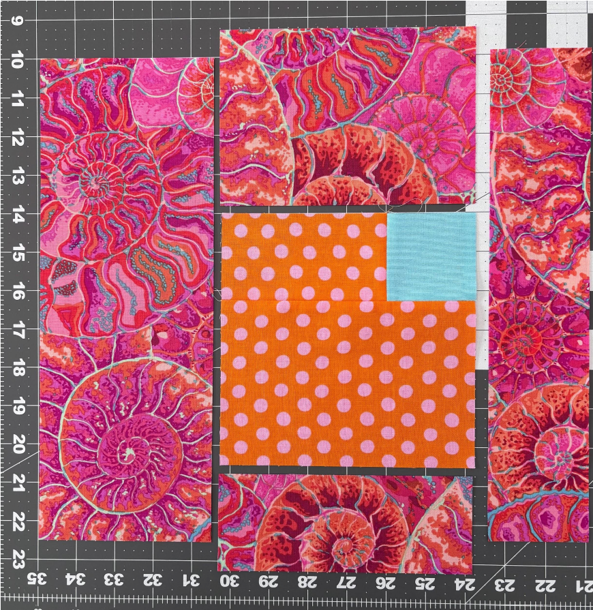
Piece the solid square to the 2-½” x 4-½” polka-dot piece; press open.

Piece that section to the larger polka-dot piece and press seams open.

Piece the top and bottom background fabrics to the polka-dot square to complete the column and press seams open.

May 2026 BOM│The One with Polka-Dots

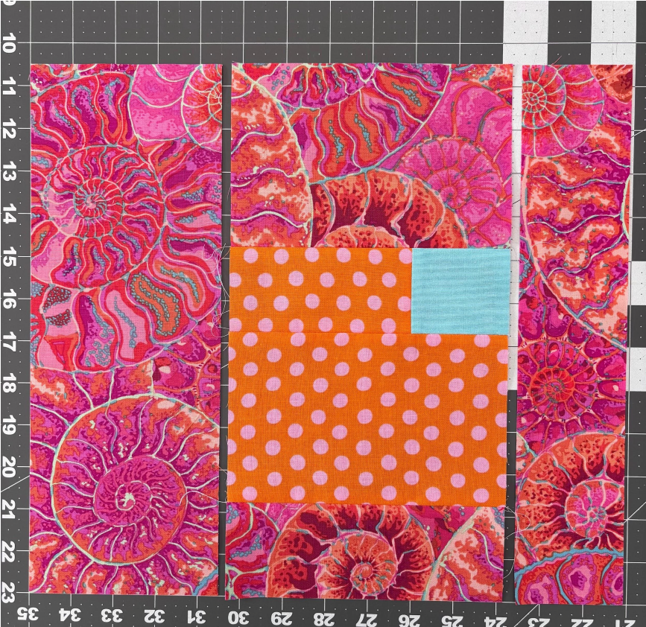
Piece the sides of the background fabric to finish the block and press seams open.

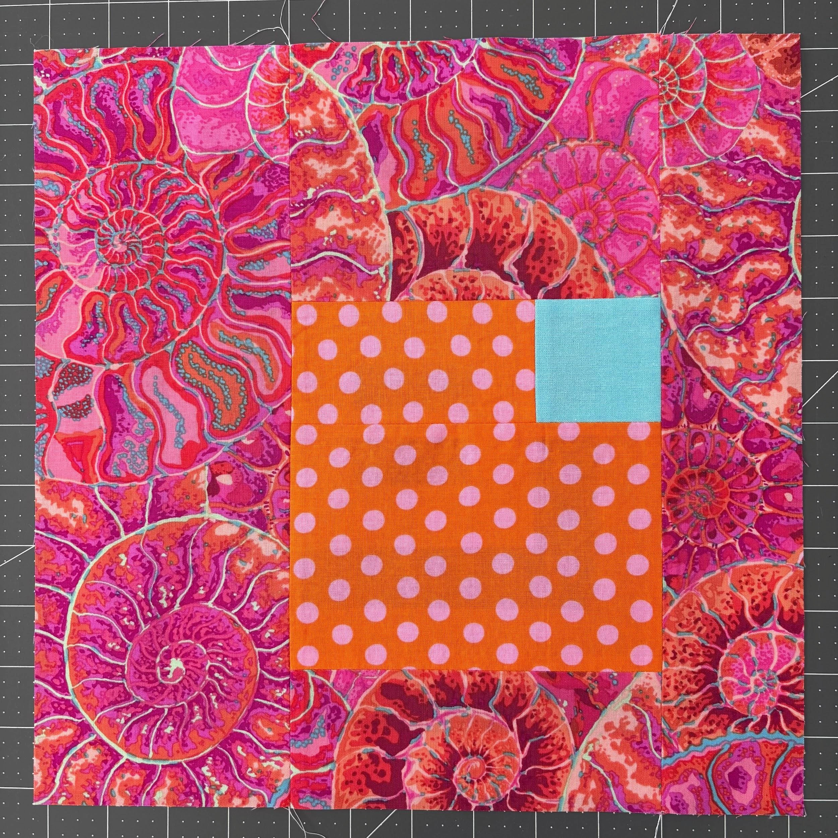

VOILA!! You will have a 12-½” square block!

